Mt. Hamilton Optics Cleaning Trip
David Hilyard and Brian DuPraw
10/3/12

KAST Gratings
The KAST camera was on the dome floor. Kostas removed the cover of the red-side camera lens (being careful not to lose the shim) and Dave cleaned the outside lens surface, which had an existing scratch. He noted that there was dust on the inside surface but it was not reachable to clean. The same was true of the blue side, except that it didn’t have a scratch.

Red side camera
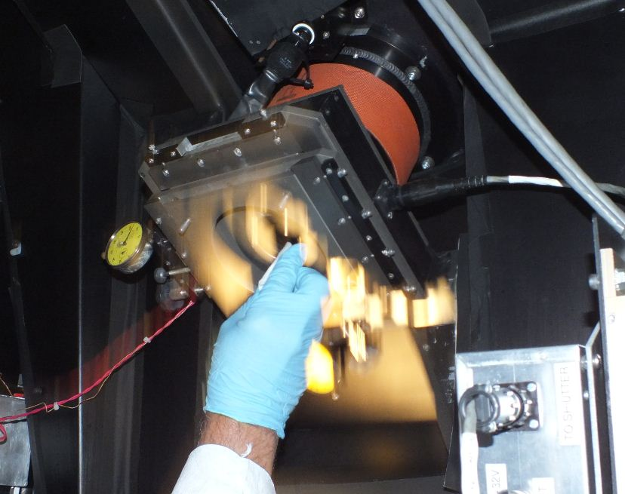

Blue side camera
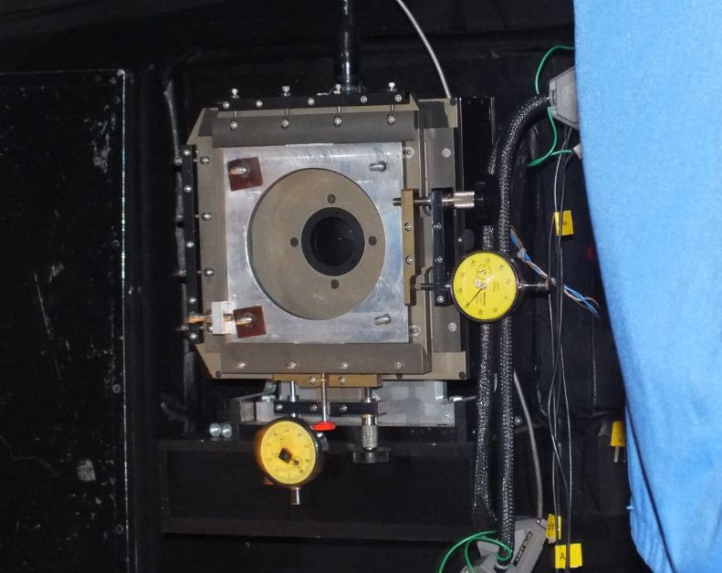

Dave also blew off the slit-jaw mechanism accessible on the top, via an access hole.
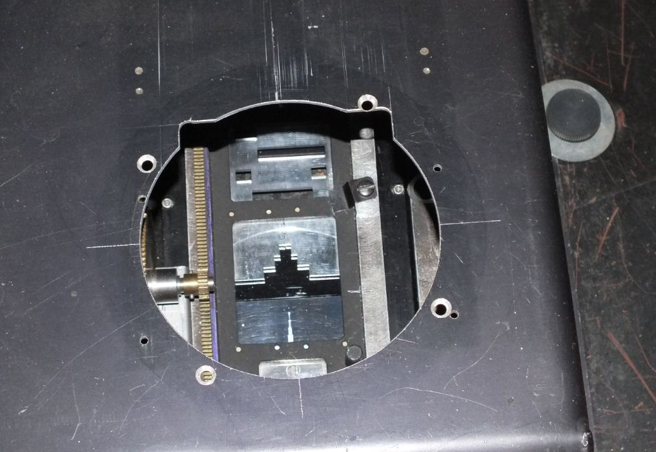

We also visited the dewars for the red and blue cameras, downstairs in the “nursery.” The red side CCD cover had some sort of stain on the inaccessible lower surface. Dave cleaned the outer surfaces of both the red and the blue CCDs.

Red CCD, before
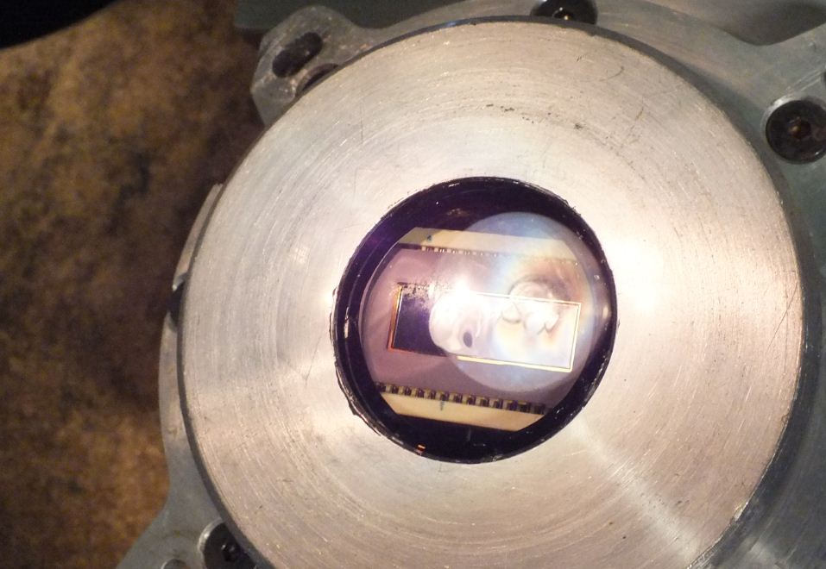

Red CCD, after cleaning
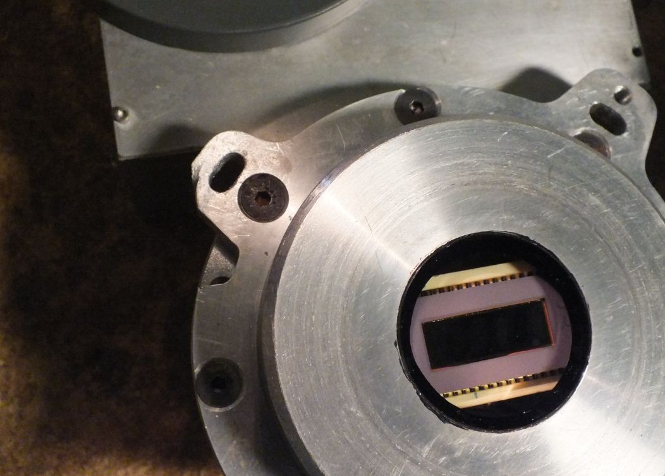

Blue CCD, before cleaning
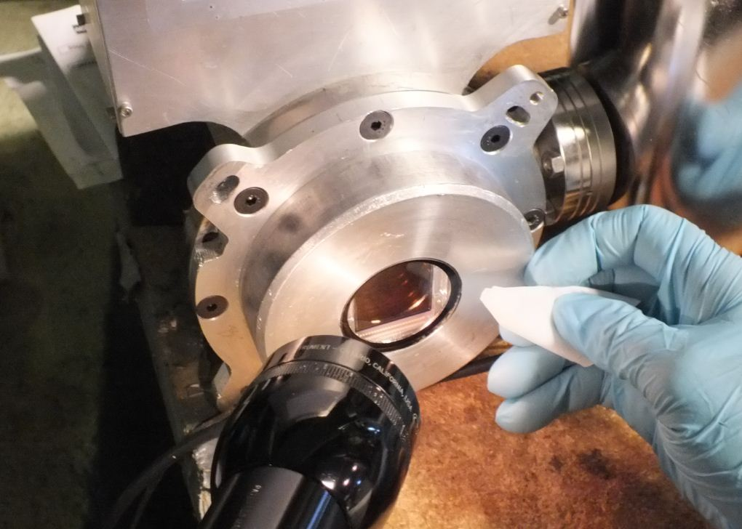

Blue CCD, after cleaning
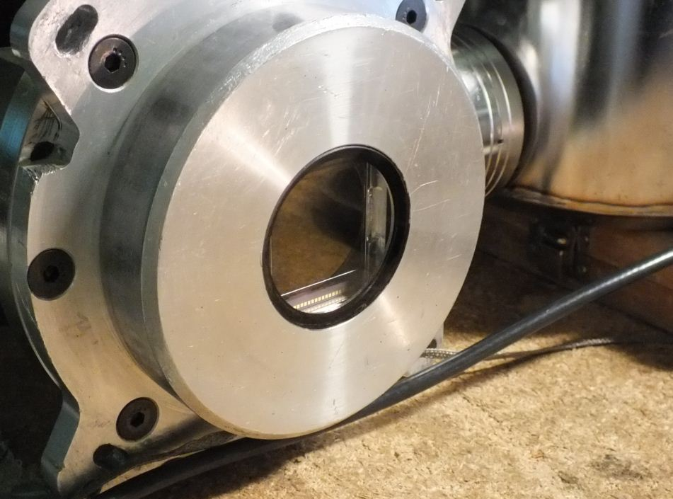

36” Refractor
The 36 inch refractor had a somewhat oily, dusty front surface. Dave dabbed it with an Orvus/acetone/H2O combination, then sprayed it with de-ionized water and dabbed that off, too. Then he followed it up with ethanol and acetone to cut the Orvus (soap). Afterward it was much improved. We opened the access panel to reach the back surface of the front lens by rotating a ring around the telescope tube. Dave cleaned what he could reach through the limited openings.

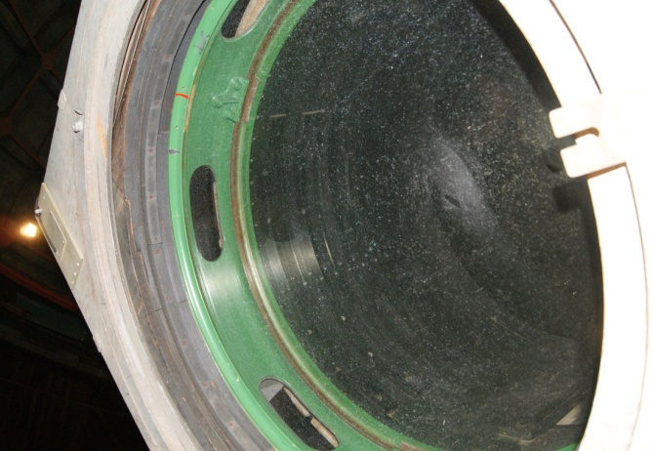

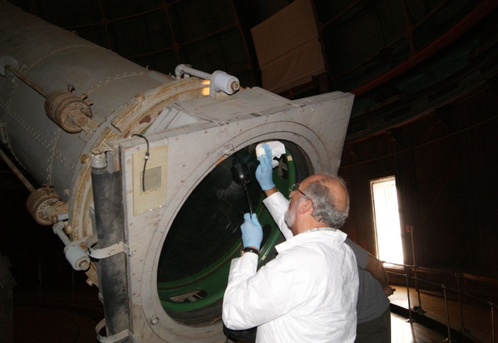

Bob opened the cover of the finder scope on the 36” and Dave cleaned the dusty first surface.
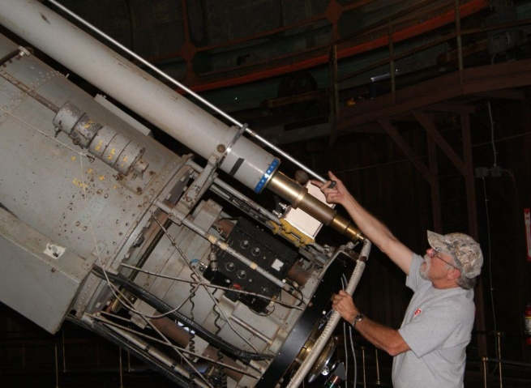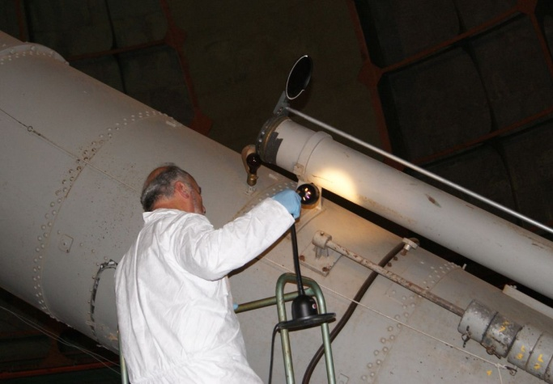

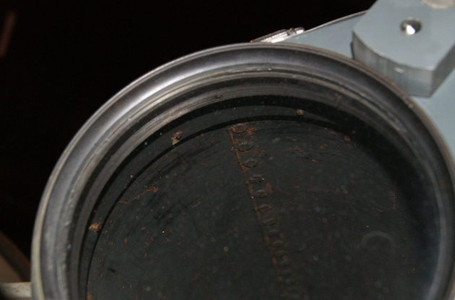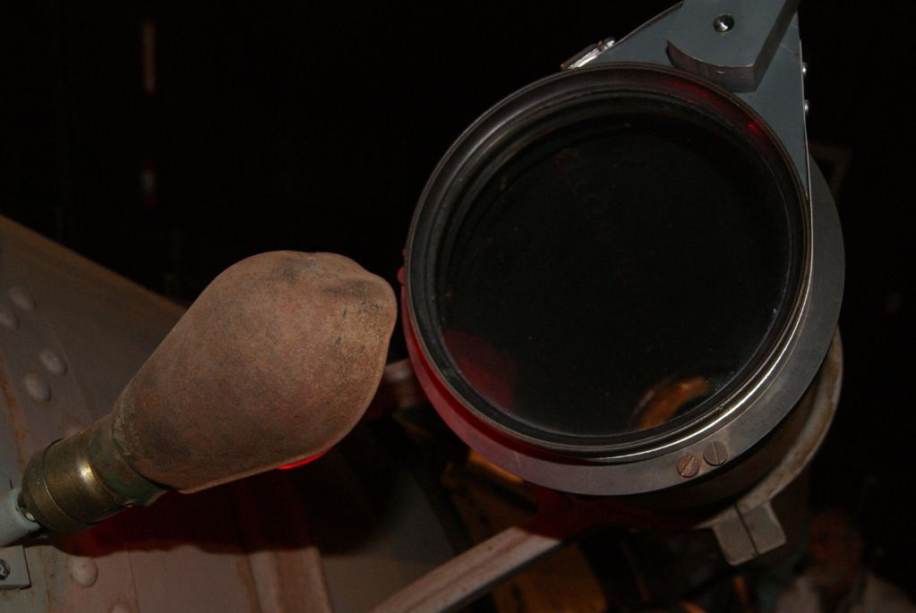

KAIT
The Katzmann Automatic Imaging Telescope was very dusty before Dave cleaned it with Orvus/acetone/H2O followed by de-ionized water and ethanol. Before cleaning, the primary’s reflectivity was measured to be 85% in the blue and 93% in the red (relative to the reference). After cleaning it was 87% in the blue and 98% in the red.

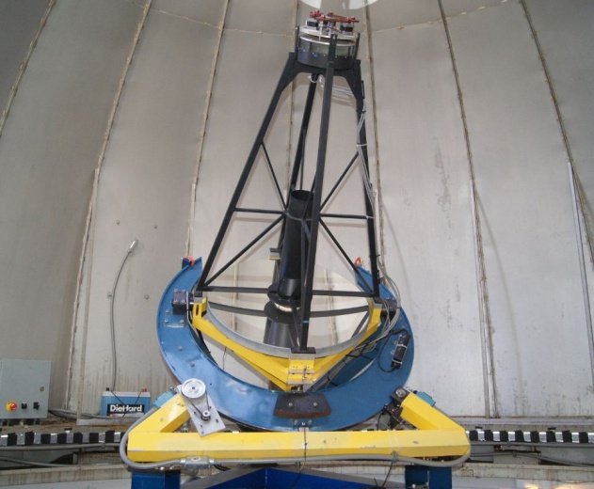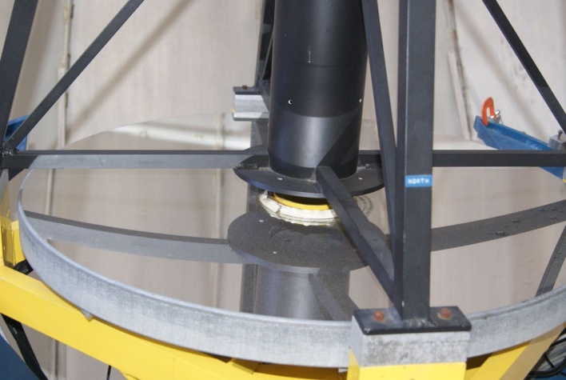

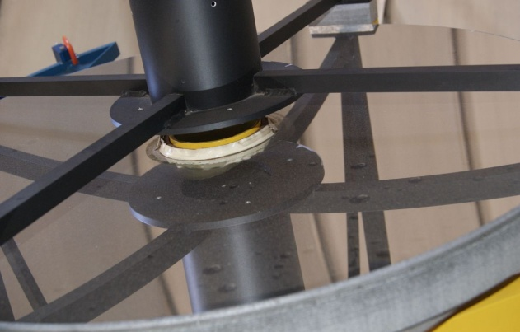

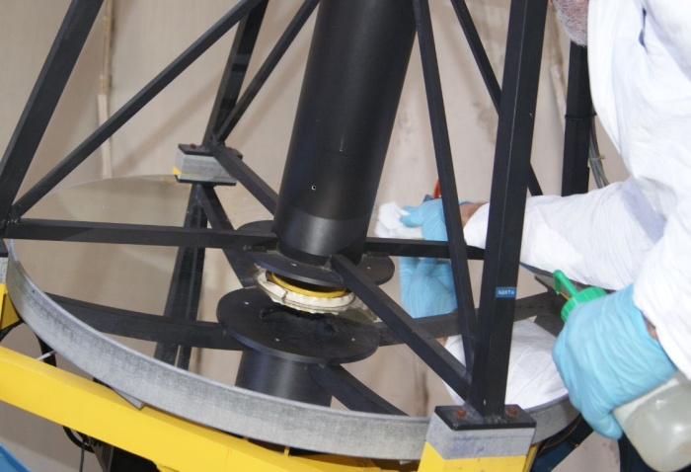

Dave also attempted to clean the KAIT secondary, but the observable spots were in the coating, rather than on top of it.
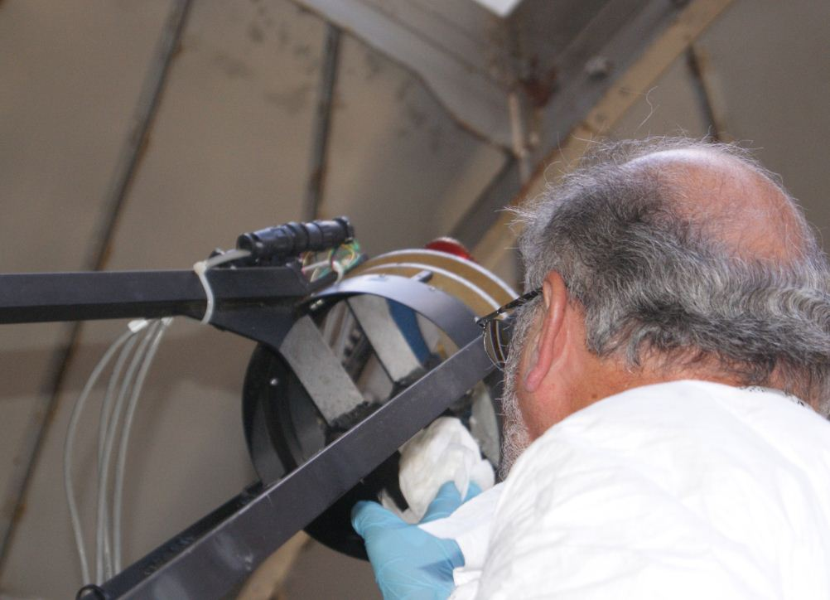

40 inch
The 40” Primary was not too dirty since the last cleaning, although the coating itself had been heavily damaged by water sometime in the past. We measured it to be 85% in the red and 79% in the blue. We did not attempt to clean it.
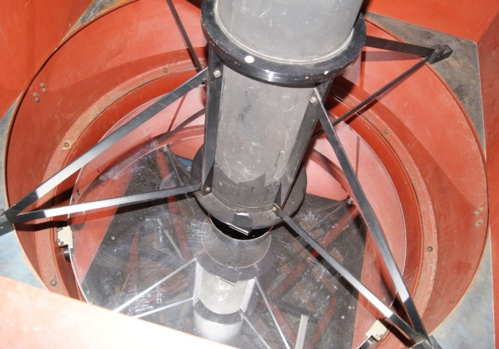

The 40” primary’s existing water spot.
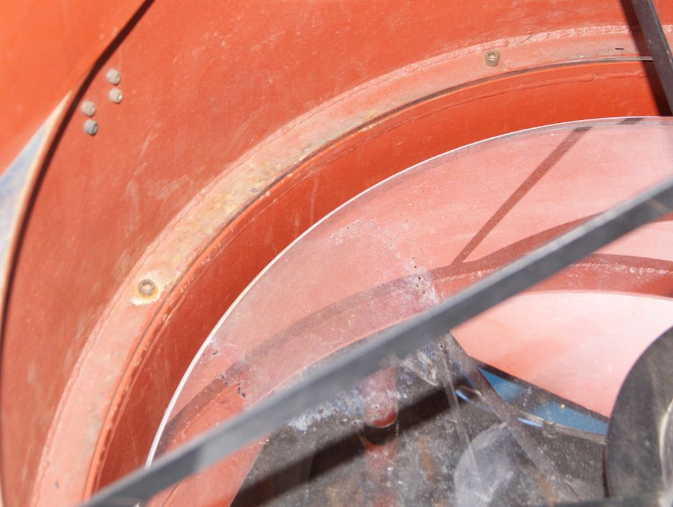

The 40” secondary mirror was measured to be 77% in the red and 78% in the blue, relative to the reference. Like the primary, it wasn’t super dirty but the coating itself was poor.
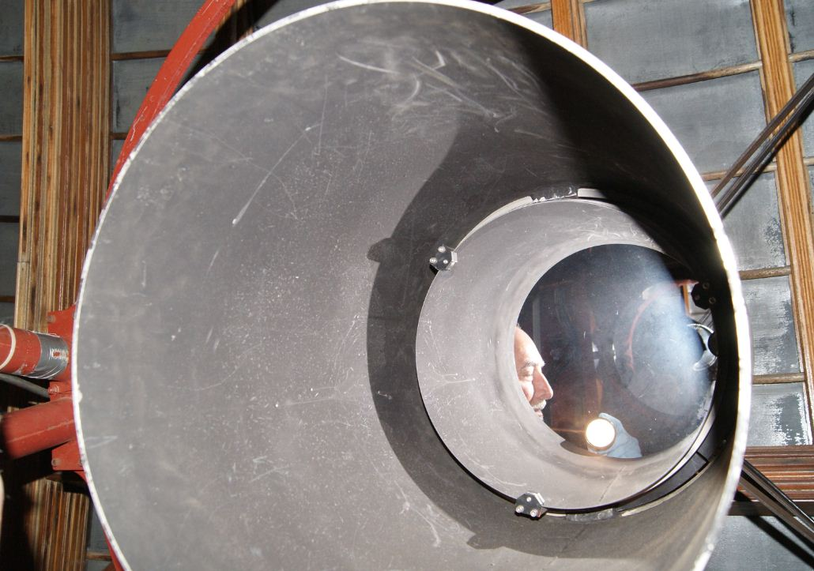

KAST Guide Mirror
This mirror was brought to us with a periscope attached. It was already very sleeky but Dave cleaned the dust off with ethanol.
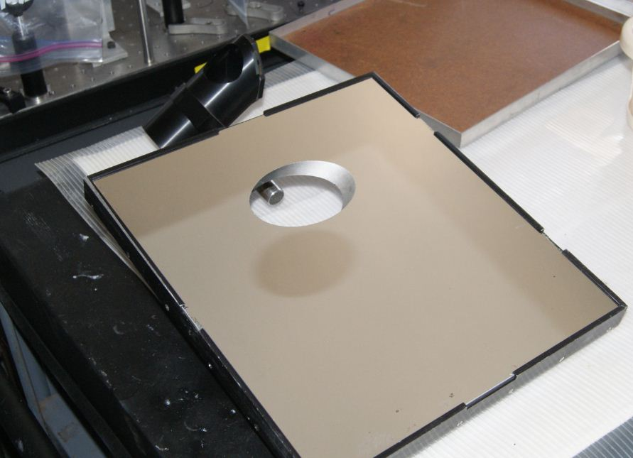

There were two particularly noticeable scratches across its face, near the center.
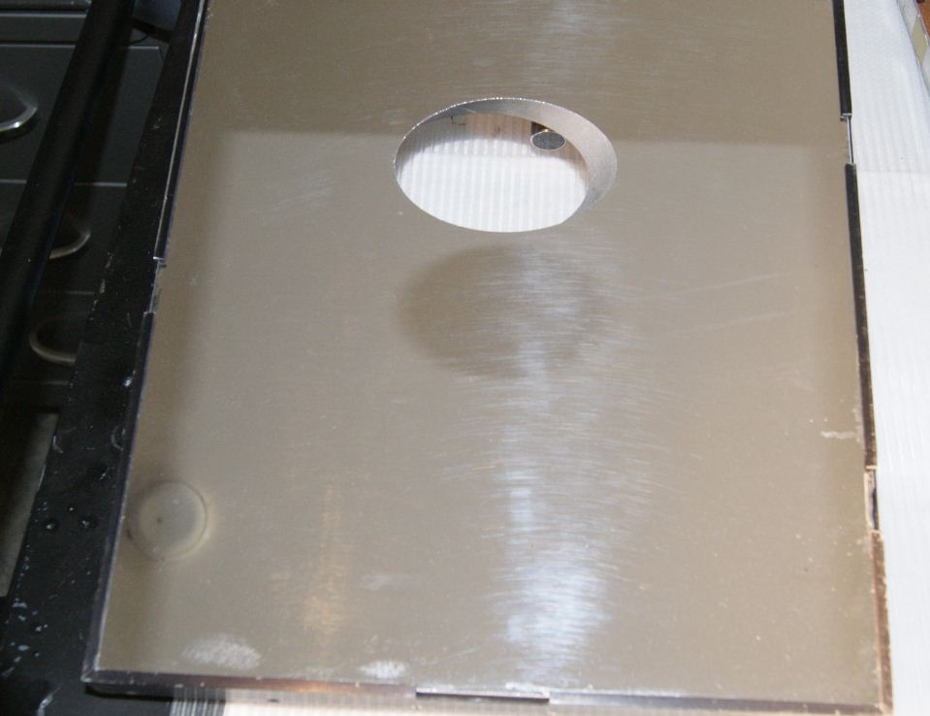

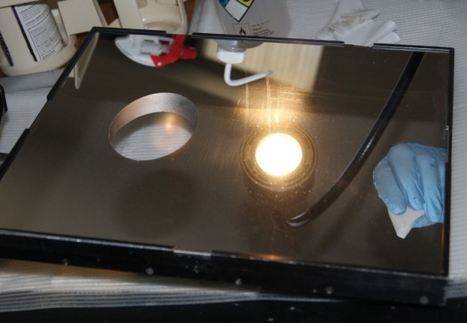
Bob and Dave also removed the hex-shaped mirror from the periscope with a flat screwdriver and Dave cleaned it and the lens that was still in the periscope tube.
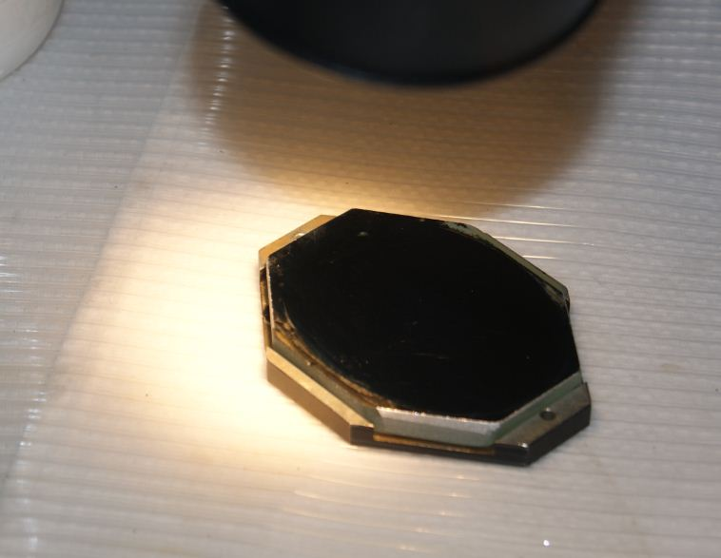

Dome Samples
There are 16 coated 2” Zerodur disks mounted to a stair landing railing above the elevator in the 120” dome; they have been undergoing a months-long observational test to see how they fare in that environment. Occasionally they get brought down for a closer look, but this time I simply photographed them.
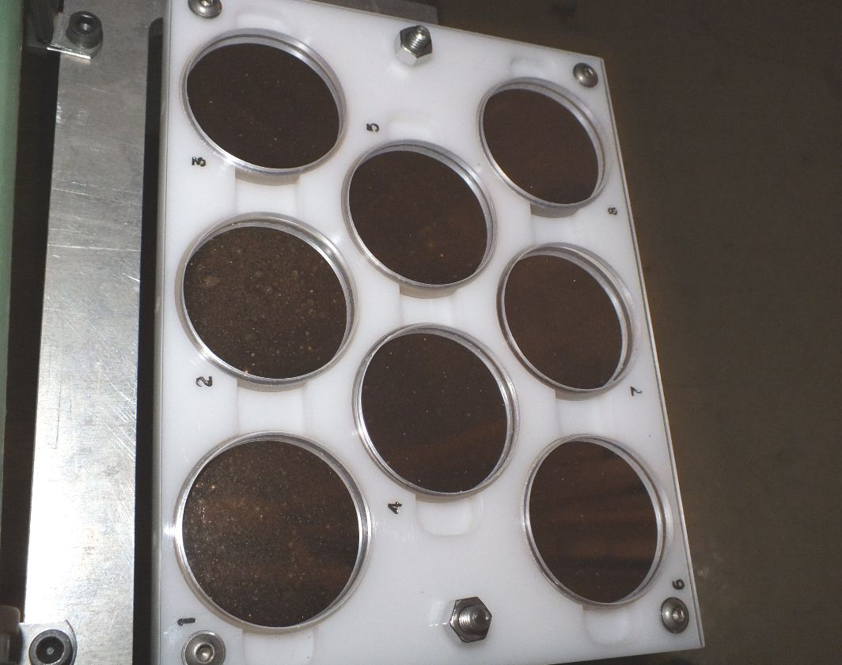

Samples 1 and 2
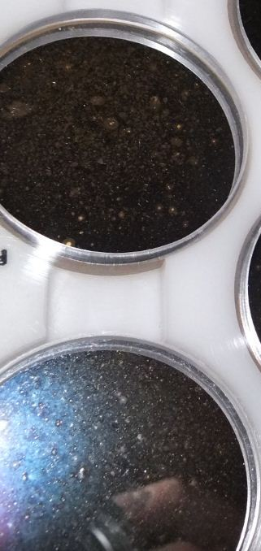

Sample 4
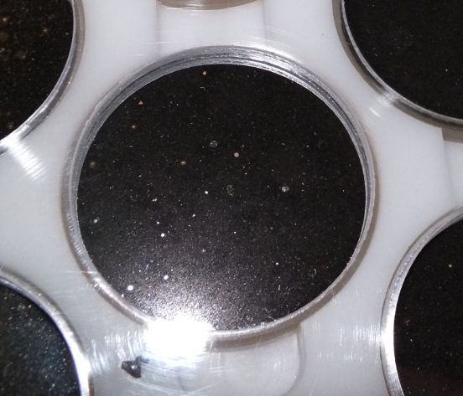

Sample 5
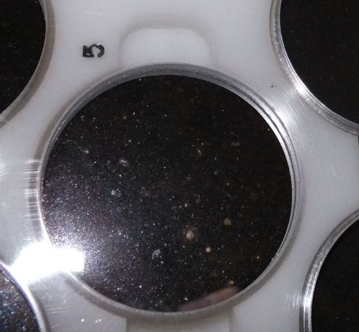

Samples 9 - 16
